Question Bank for CIE- I

Unit- II
- Explain concept of verification and validation
- Explain levels of testing
- Explain Testing Life cycle in detail.
- Write note on - Test-Driven Development(TDD), Behavior-Driven Development(BDD), and Acceptance Test-Driven Development(ATDD)
- Develop test cases for ATM system/online shopping/flight booking system/Railway reservation system
- Construct test plan for ATM system/online shopping/flight booking system/Railway Reservation System
- Explain Bug life cycle
- What is defect repository? Explain with suitable example.
- Explain Testing Life cycle in detail.
- Develop test case for Username and Password

Explain concept of verification and validation
Verification and Validation (V&V) are two important concepts in software engineering and quality assurance used to ensure that a software system meets its requirements and performs as expected.

1. Verification – “Are we building the product right?”
Definition:
Verification is the process of evaluating software during development to ensure that it meets the specified requirements and design specifications.

Key Features:
- Focuses on process and intermediate work products (like design documents, source code, etc.)
- Ensures that the software is being built correctly according to requirements.
- Conducted through reviews, inspections, walkthroughs, and desk-checking.
- Does not involve executing the code.
Examples of Verification:
- Requirements review
- Design review
- Code inspection
- Static analysis

2. Validation – “Are we building the right product?”
Definition:
Validation is the process of evaluating the final software product to ensure that it meets the business needs and user expectations.
Key Features:
- Focuses on the actual product.
- Ensures that the right product has been built for the customer.
- Involves executing the software and checking if it behaves as expected.
- Performed through testing (unit testing, system testing, user acceptance testing, etc.)
Examples of Validation:
- System testing
- Integration testing
- User Acceptance Testing (UAT)
- Beta testing

Comparison Table:
Aspect | Verification | Validation
Purpose | Are we building the product right? | Are we building the right product?
Focus | Process-oriented | Product-oriented
Activities | Reviews, walkthroughs, inspections | Testing and execution
Timing | During development | After implementation
Performed by | Developers, QA, project team | Testers, end users, QA
Execution of code | Not required | Required
Summary:
- Verification ensures that the product is developed correctly.
- Validation ensures that the correct product is developed.
Both are essential for delivering high-quality, reliable software.

Explain levels of testing

Levels of Testing in Software Engineering
Software testing is performed in multiple levels to ensure that errors are identified early and the software works correctly as a whole.
Each level focuses on a different aspect of the system.

🔹 1. Unit Testing
Definition:
Testing individual components or modules of a program in isolation to ensure they work as expected.

Focus:
- Smallest testable parts like functions, classes, or methods.

Who performs it?
- Developers
Tools:
- JUnit (Java), NUnit (.NET), PyTest (Python), etc.
Example:
Testing a function that calculates the sum of two numbers.

🔹 2. Integration Testing
Definition:
Testing the interaction between two or more integrated units or modules.

Focus:
- Data flow and interfaces between modules.
0
Who performs it?
- Developers or testers
Approaches:
- Top-down
- Bottom-up
- Big bang
- Sandwich
Example:
Testing the login module interacting with the user authentication system.

3. System Testing
Definition:
Testing the complete and integrated software system to ensure it meets the specified requirements.

Focus:
- End-to-end testing of the whole application.
Who performs it?
- Independent testing team
Types:
- Functional testing
- Non-functional testing (performance, security, etc.)
Example:
Testing an entire e-commerce website from login to payment checkout.

4. Acceptance Testing
Definition:
Testing to validate the software against user needs and business requirements.

Focus:
- Final validation before the software goes live.
Who performs it?
- End users or clients
Types:
- Alpha Testing (in development environment)
- Beta Testing (in real-world environment)
Example:
A client tests an inventory management system before deploying it in the warehouse.

Summary Table:
Level | Focus | Performed By | Purpose
Unit Testing | Individual modules/  functions | Developers | Ensure each unit works correctly
Integration Testing | Interfaces between units | Developers/Testers | Ensure combined units work together properly
System Testing | Complete system | Independent testers | Ensure system meets functional and non-functional requirements
Acceptance Testing | User/business requirements | End-users/Clients | Ensure the system is ready for release

- Explain Testing Life cycle in detail.

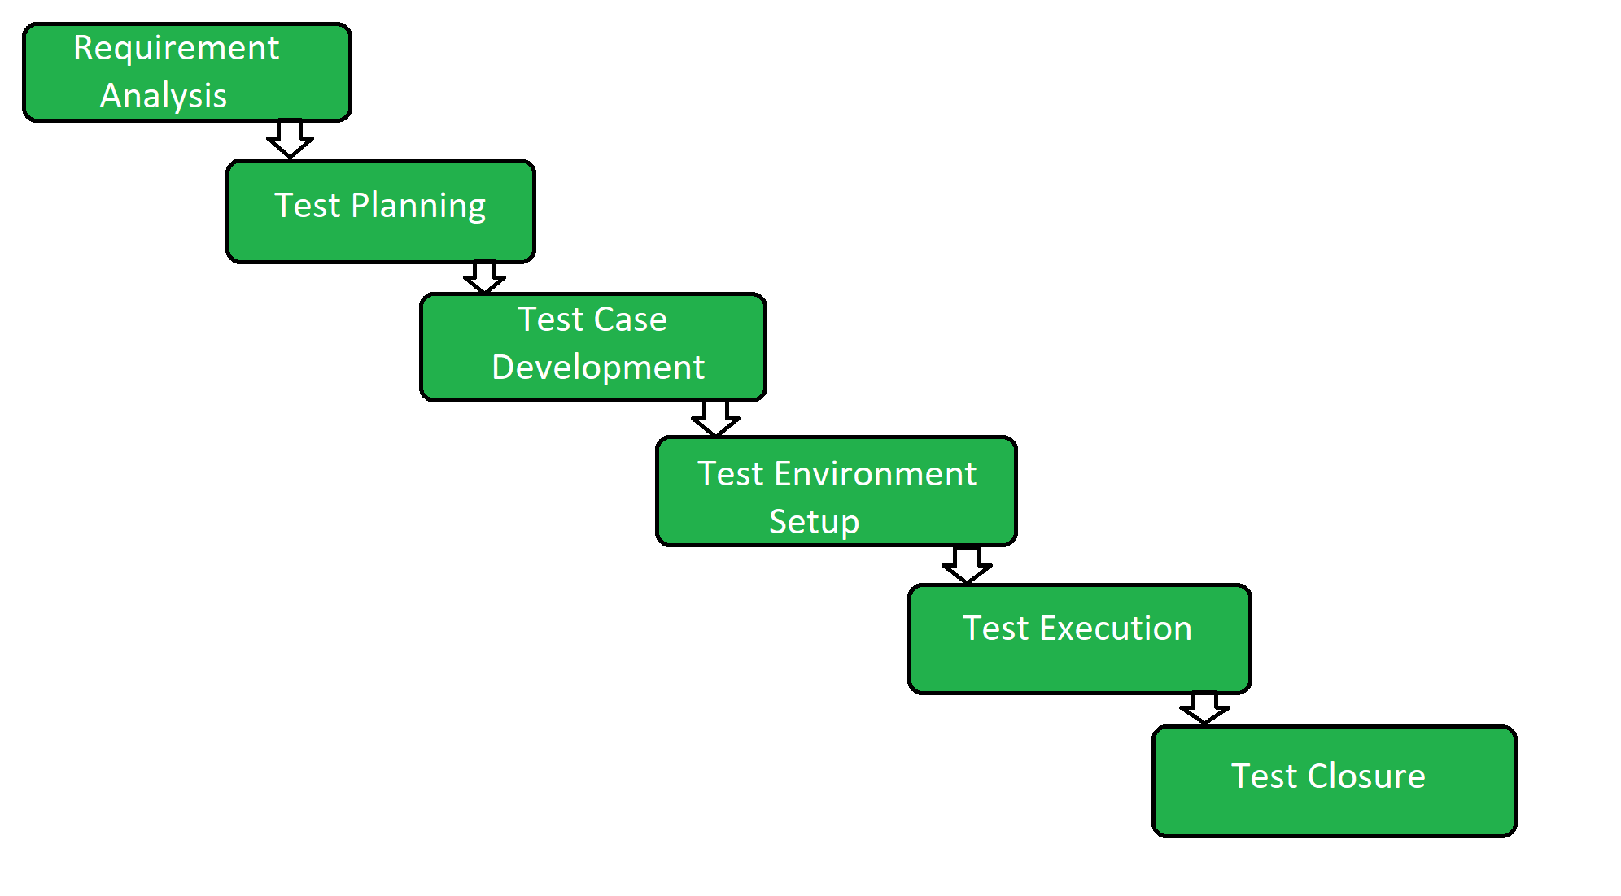

Key Phases of STLC:
- Requirement Analysis: Understanding the testing requirements, including functional and non-functional aspects.
- Test Planning: Defining the overall testing strategy, scope, resources, and timelines.
- Test Case Development: Creating detailed test cases to cover various scenarios and functionalities.
- Environment Setup: Configuring the necessary hardware and software environment for testing.
- Test Execution: Running the test cases and logging the results.
- Test Cycle Closure: Analyzing test results, reporting defects, and preparing a test closure report.

------------------------------------------------------------------------------------------------------------------------------------

Software Testing Life Cycle (STLC) – Detailed Explanation
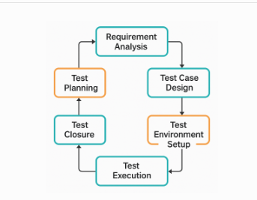
The Software Testing Life Cycle (STLC) is a sequence of specific activities conducted during the testing process to ensure software quality goals are met. Each phase has defined objectives and deliverables, ensuring a structured and efficient approach to software testing.

Phases of the Testing Life Cycle:

1. Requirement Analysis
Objective:
Understand and analyze the testing requirements based on software requirement specifications (SRS), business requirements, or use cases.
Activities:
- Identify testable requirements.
- Communicate with stakeholders to clarify doubts.
- Determine types of tests (functional, performance, security, etc.)
Deliverables:
- Requirement Traceability Matrix (RTM)
- Automation feasibility report (if applicable)

2. Test Planning
Objective:
Define the scope, objectives, approach, resources, and schedule for testing activities.
Activities:
- Create a test strategy and test plan.
- Estimate effort and time.
- Define roles and responsibilities.
- Identify testing tools and environment needs.
Deliverables:
- Test Plan document
- Effort estimation
- Risk and mitigation plan

3. Test Case Design / Test Development
Objective:
Design detailed test cases and test scripts covering all functional and non-functional requirements.
Activities:
- Write test cases with input data and expected results.
- Design test data.
- Review and get approval for test cases.
Deliverables:
- Test cases/scripts
- Test data
- Updated RTM

4. Test Environment Setup
Objective:
Prepare the hardware and software environment in which tests will be executed.
Activities:
- Install and configure software, database, servers.
- Set up network, user accounts, access rights.
- Validate the test environment.
Deliverables:
- Environment setup checklist
- Smoke test result to confirm readiness

5. Test Execution
Objective:
Run the test cases and compare actual vs. expected results.
Activities:
- Execute manual or automated test cases.
- Log defects in defect tracking tool.
- Retest and perform regression testing.
Deliverables:
- Test execution report
- Defect reports
- Updated RTM

6. Test Closure
Objective:
Summarize and evaluate testing efforts and results to confirm completion.
Activities:
- Finalize test reporting.
- Document lessons learned.
- Archive test artifacts for future use.
- Review test deliverables.
Deliverables:
- Test summary report
- Defect closure report
- Test metrics
- Test closure document

Summary Table:
Phase | Key Activities | Key Deliverables
Requirement Analysis | Analyze and identify test requirements | RTM, feasibility report
Test Planning | Define scope, tools, schedule, and responsibilities | Test Plan, estimation, risk plan
Test Case Design | Write and review test cases and test data | Test cases, test data, updated RTM
Test Environment Setup | Prepare environment and validate configuration | Environment setup checklist, smoke test
Test Execution | Execute tests, log defects, retest, regression testing | Test execution report, defect log
Test Closure | Analyze test results, report metrics, document learnings | Test summary report, test closure report

Importance of STLC:
- Ensures systematic and consistent testing
- Helps identify defects early
- Improves software quality
- Reduces cost and time of defect fixing

Write note on - Test-Driven Development(TDD), Behavior-Driven Development(BDD), and Acceptance Test-Driven Development(ATDD)

1. Test-Driven Development (TDD)
Definition:
TDD is a software development approach where tests are written before the code. The idea is to write a failing test case first, then write code to pass the test, and finally refactor the code.
Process (Red-Green-Refactor cycle):
- Red – Write a failing test case.
- Green – Write minimal code to pass the test.
- Refactor – Improve the code while ensuring tests still pass.
Benefits:
- Ensures better test coverage.
- Encourages modular and flexible code.
- Bugs are caught early.
Tools:
JUnit (Java), NUnit (.NET), PyTest (Python)

2. Behavior-Driven Development (BDD)
Definition:
BDD is an extension of TDD that emphasizes collaboration between developers, testers, and business stakeholders. It describes the system's behavior using natural language.
Process:
- Define behavior in a "Given-When-Then" format (using Gherkin language).
- Convert scenarios into automated tests.
- Write code that satisfies the defined behavior.
Example:
pgsql
CopyEdit
Given a logged-in user
When they add an item to the cart
Then the item should appear in the cart
Benefits:
- Improves communication between teams.
- Provides clear documentation.
- Focuses on business value.
Tools:
Cucumber, SpecFlow, Behave

3. Acceptance Test-Driven Development (ATDD)
Definition:
ATDD involves writing acceptance tests before development begins, based on customer and business requirements. All stakeholders collaborate to define the expected behavior.
Process:
- Discuss and agree on acceptance criteria.
- Write acceptance tests.
- Develop the system to pass those tests.

Focus:
- Meeting business needs and user acceptance.
Benefits:
- Reduces misunderstandings.
- Ensures the system aligns with user expectations.
- Enhances test coverage from the user's point of view.
Tools:
FitNesse, Robot Framework, Cucumber

Summary Table:
Approach | Written By | Written Before | Focus Area | Tools
TDD | Developers | Development | Code correctness | JUnit, PyTest
BDD | Developers + QA + BA | Development | Behavior from user view | Cucumber
ATDD | Developers + Testers + Customers | Development | Acceptance criteria | FitNesse, Cucumber

- Develop test cases for ATM system/online shopping/flight booking system/Railway reservation system

Online Shopping System – Sample Test Cases
Test Case ID | Test Scenario / Feature | Test Steps | Expected Result
SHOP_TC_01 | User Registration | Fill registration form with valid data and submit | Account is successfully created and confirmation message shown
SHOP_TC_02 | Registration with missing fields | Leave mandatory field (e.g., email) blank and submit | Validation error shown: "Email is required"
SHOP_TC_03 | Login with valid credentials | Enter correct username and password | User is redirected to the home/dashboard page
SHOP_TC_04 | Login with invalid password | Enter valid username and wrong password | Error message shown: "Invalid credentials"
SHOP_TC_05 | Product Search | Type product name in search bar and click search | List of relevant products is displayed
SHOP_TC_06 | Add product to cart | Click "Add to Cart" on a displayed product | Product is added to cart and cart count is updated
SHOP_TC_07 | View Cart | Click on "Cart" icon | Cart page shows all added products
SHOP_TC_08 | Remove product from cart | Click "Remove" on a product in cart | Product is removed, cart is updated
SHOP_TC_09 | Apply valid coupon code | Enter valid promo code during checkout | Discount is applied to the total amount
SHOP_TC_10 | Apply invalid coupon code | Enter expired or incorrect promo code | Error message shown: "Invalid or expired coupon code"
SHOP_TC_11 | Checkout with valid details | Fill delivery address, select payment, confirm order | Order placed successfully with order confirmation message
SHOP_TC_12 | Checkout with missing delivery address | Leave delivery address blank during checkout | Validation error shown: "Address is required"
SHOP_TC_13 | Payment with invalid card | Enter incorrect card number or expiry date | Payment fails and error message is shown
SHOP_TC_14 | Payment with valid card | Enter valid card details and proceed | Payment is successful, redirected to order confirmation
SHOP_TC_15 | View Order History | Login → Navigate to "My Orders" | All past orders are listed with status
SHOP_TC_16 | Cancel an Order | Go to "My Orders" → Select order → Click "Cancel" | Order is cancelled and status updated to "Cancelled"
SHOP_TC_17 | Logout Functionality | Click on "Logout" after login | User is logged out and redirected to the login page

📌 Optional Enhancements:
You can expand these with:
- Preconditions (e.g., user must be logged in)
- Test Data
- Expected vs Actual Result
- Priority/Severity Tags
Let me know if you'd like this in Excel, PDF, or as a test plan template.
module-wise breakdown of test cases for an Online Shopping System, organized into key modules:

1. User Registration & Login Module
Test Case ID | Test Scenario | Test Steps | Expected Result
REG_TC_01 | Valid user registration | Enter valid Name, Email, Password, Phone → Submit | "Registration successful" message appears
REG_TC_02 | Registration with missing fields | Leave Email blank → Submit | Validation error: "Email is required"
REG_TC_03 | Registration with invalid email format | Enter abc@xyz without domain → Submit | Validation error: "Enter a valid email address"
REG_TC_04 | Login with correct credentials | Enter correct Email and Password → Login | Redirect to homepage/dashboard
REG_TC_05 | Login with incorrect password | Enter registered Email and wrong password → Login | "Invalid credentials" error message
REG_TC_06 | Password recovery | Click "Forgot Password" → Enter Email | Password reset link sent to registered email

2. Product Browsing and Search Module
Test Case ID | Test Scenario | Test Steps | Expected Result
BROWSE_TC_01 | View product categories | Click on "Electronics", "Clothing", etc. | Products under selected category displayed
BROWSE_TC_02 | Search for a product | Enter "Laptop" in search bar → Click search | Matching laptop products displayed
BROWSE_TC_03 | Search with no matching result | Enter random string like "xyz123" → Search | Message: "No products found"
BROWSE_TC_04 | View product details | Click on a product | Detailed product page with description, price shown
BROWSE_TC_05 | Sort products by price (low to high) | Click "Sort by: Price – Low to High" | Products sorted accordingly

3. Shopping Cart Module
Test Case ID | Test Scenario | Test Steps | Expected Result
CART_TC_01 | Add product to cart | On product page → Click "Add to Cart" | Product added, cart count increases
CART_TC_02 | View cart | Click on "Cart" icon | List of added products shown
CART_TC_03 | Change product quantity | In cart → Increase quantity to 2 | Total amount updates correctly
CART_TC_04 | Remove product from cart | Click "Remove" next to a product | Product removed, total updates
CART_TC_05 | Cart with no products | Remove all items | Message: "Your cart is empty"

4. Wishlist Module
Test Case ID | Test Scenario | Test Steps | Expected Result
WISH_TC_01 | Add item to wishlist | On product page → Click “Add to Wishlist” | Product added to wishlist
WISH_TC_02 | View wishlist | Go to "Wishlist" section | All saved items are shown
WISH_TC_03 | Move product from wishlist to cart | Click “Move to Cart” | Item removed from wishlist and added to cart
5. Checkout and Payment Module
Test Case ID | Test Scenario | Test Steps | Expected Result
PAY_TC_01 | Proceed to checkout | Click "Checkout" from cart | Redirect to address & payment screen
PAY_TC_02 | Enter valid shipping address | Fill in address, city, pin code → Continue | Address saved successfully
PAY_TC_03 | Apply valid coupon | Enter valid coupon code → Apply | Discount is reflected in total price
PAY_TC_04 | Apply invalid coupon | Enter expired or wrong code → Apply | Error: "Invalid coupon code"
PAY_TC_05 | Pay with valid credit/debit card | Enter correct card details → Confirm | Payment succeeds, order placed
PAY_TC_06 | Pay with invalid card | Enter fake card number or expired card | Payment fails with appropriate message

6. Order Management Module
Test Case ID | Test Scenario | Test Steps | Expected Result
ORDER_TC_01 | View order confirmation | After successful payment → Show confirmation | Order ID, summary, delivery estimate shown
ORDER_TC_02 | View past orders | Go to "My Orders" | List of past orders with statuses shown
ORDER_TC_03 | Cancel pending order | Click "Cancel" on an unpaid or processing order | Status updated to "Cancelled"
ORDER_TC_04 | View order invoice | Click "Invoice" for a completed order | Invoice PDF/HTML shown

7. User Profile Module
Test Case ID | Test Scenario | Test Steps | Expected Result
PROFILE_TC_01 | View and edit profile | Login → Go to “My Profile” → Edit name/phone | Profile updated successfully
PROFILE_TC_02 | Change password | Old password + new password → Submit | Password changed confirmation shown
PROFILE_TC_03 | Save default shipping address | Enter and save address in profile settings | Address saved and used in future orders

8. Logout and Session Handling
Test Case ID | Test Scenario | Test Steps | Expected Result
SESSION_TC_01 | Logout | Click on "Logout" | Redirected to login page
SESSION_TC_02 | Session timeout | Stay idle for 15+ minutes | Auto logout with session timeout message

Flight reservation system

1. Flight Search Module
Test Case ID | Test Scenario | Test Steps / Input | Expected Result
FS_TC_01 | Search valid flight | Source: Pune, Destination: Delhi, Date: 15/08/2025 | Show list of available flights
FS_TC_02 | Invalid source/destination | Source: Abcxyz | Show error: “Invalid city name”
FS_TC_03 | Empty search fields | Click search with all fields blank | Show validation message
FS_TC_04 | Search for past date | Date: 01/01/2024 | Show error: “Invalid travel date”

2. Passenger Details Module
Test Case ID | Test Scenario | Test Steps / Input | Expected Result
PD_TC_01 | Valid passenger information | Fill: Name, Gender, Age, ID | Proceeds to payment
PD_TC_02 | Missing required fields | Leave name or ID blank | Show validation message
PD_TC_03 | Multiple passengers entry | Add 3 passengers with correct details | All passengers added successfully

3. Payment Module
Test Case ID | Test Scenario | Test Steps / Input | Expected Result
PM_TC_01 | Valid credit card payment | Card No: valid, CVV, Expiry | Payment success, ticket issued
PM_TC_02 | Invalid card details | Wrong card no./expired date | Show error: Payment failed
PM_TC_03 | Cancel during payment | Click "Cancel" on payment screen | Booking not confirmed

4. Ticket Confirmation Module
Test Case ID | Test Scenario | Test Steps / Input | Expected Result
TC_TC_01 | Check booking confirmation | Book a flight, go to “My Bookings” | Show ticket and booking details
TC_TC_02 | Email/SMS notification | Book ticket, check inbox | Email/SMS with ticket sent

5. Ticket Cancellation Module
Test Case ID | Test Scenario | Test Steps / Input | Expected Result
CN_TC_01 | Cancel ticket before departure | Click "Cancel" under booking before flight time | Show confirmation and refund status
CN_TC_02 | Cancel expired ticket | Try cancelling after flight time | Error: Cancellation not allowed

6. Admin Panel Module
Test Case ID | Test Scenario | Test Steps / Input | Expected Result
AP_TC_01 | Admin login | Username: admin, Password: pass123 | Dashboard opens
AP_TC_02 | Add new flight | Fill flight details → Save | Flight appears in search
AP_TC_03 | Edit flight schedule | Update departure time or price | Changes reflected for users

7. Security Module
Test Case ID | Test Scenario | Test Steps / Input | Expected Result
SC_TC_01 | SQL injection attempt in input field | Input: ' OR 1=1 -- in search field | Input rejected, app remains secure
SC_TC_02 | Unauthorized admin access | Try opening admin page without login | Redirect to login page or access denied

Test plan

Test Plan for Flight Booking System (Applicable to other systems too)

1. Test Plan ID:
TP-FBS-001

2. Project Title:
Flight Booking System

3. Objective:
To verify the functionality, usability, performance, and security of the Flight Booking System and ensure it meets the specified requirements.

4. Scope of Testing:
In Scope:
- Flight search and selection
- Passenger data input
- Booking and payment process
- Ticket confirmation and email
- Booking cancellation and refund
- Admin panel functions
Out of Scope:
- Backend airline system API testing (if outsourced)
- Testing third-party payment gateway internals

5. Test Items:
- Flight Search Function
- Flight Selection
- Passenger Data Entry
- Payment Integration
- Ticket Generation
- Booking History
- Admin Module (Add/Edit/Remove Flights)
- Email/SMS Notifications
- Cancellation and Refund

6. Features to Be Tested:
Feature | Description
Search Flights | Based on source, destination, and date
Booking | Select flight, input details, and confirm
Payment | Process using valid and invalid cards
Confirmation | Generate ticket and notify customer
Admin Module | Manage flight schedule and fares
Security | Authentication and input validation

7. Features Not to Be Tested:
- Backend airline API logic
- Third-party SMS/email delivery systems
- Non-functional requirements outside QA scope (like UI design consistency unless part of UX testing)

8. Test Approach:
- Functional Testing: Validate all business rules and workflows
- System Testing: End-to-end test of the booking journey
- Integration Testing: Check interfaces between modules
- Usability Testing: Verify the system is user-friendly
- Security Testing: SQL injection, login access control
- Regression Testing: Re-test after bug fixes or updates

9. Entry Criteria:
- Requirements are finalized and approved
- Test environment is ready
- Test cases are prepared and reviewed
- Unit testing is completed

10. Exit Criteria:
- All critical test cases passed
- No high or critical severity defects open
- Test summary report reviewed and accepted
- Sign-off from QA lead/client

11. Test Deliverables:
- Test Plan
- Test Cases and Test Scripts
- Defect Log
- Daily/Weekly Test Reports
- Final Test Summary Report
- Sign-off Document

12. Testing Schedule:
Activity | Start Date | End Date
Test Planning | 01-Aug-2025 | 03-Aug-2025
Test Case Writing | 03-Aug-2025 | 06-Aug-2025
Test Execution | 07-Aug-2025 | 14-Aug-2025
Reporting & Closure | 15-Aug-2025 | 16-Aug-2025

13. Environment Needs:
- Web browser (Chrome, Firefox)
- Database: MySQL/PostgreSQL
- Application server
- Internet connection
- Admin and test user credentials

14. Roles and Responsibilities:
Role | Responsibility
QA Lead | Overall test planning and monitoring
QA Tester | Write and execute test cases
Developer | Fix defects and support testing
Client/Stakeholder | Review test outcomes and sign off

15. Risks and Mitigation:
Risk | Mitigation
Delay in requirement finalization | Buffer added to schedule
Unstable test environment | Coordinate with DevOps for backups
Third-party services are down | Use stubs/mocks for testing

16. Approval:
Name | Role | Signature
[QA Lead] | QA Lead
[Project Manager] | PM
[Client/Stakeholder] | Product Owner

TEST PLAN FOR ATM SYSTEM

1. Test Plan ID
TP-ATM-001

2. Project Title
Automated Teller Machine (ATM) System

3. Objective
To verify that the ATM software functions correctly, securely, and reliably across all supported transactions, and meets both functional and non-functional requirements.

4. Scope of Testing
In Scope:
- Card insertion and PIN validation
- Balance inquiry
- Cash withdrawal and deposit
- Mini statement
- Fund transfer
- Session timeout
- Receipt printing
Out of Scope:
- ATM hardware testing (card reader, cash dispenser)
- Bank core backend system (handled by integration team)

5. Test Items
- Login/Authentication module
- Transaction processing module (withdrawal, deposit, balance)
- Funds transfer module
- Mini statement module
- Receipt generation module
- Error handling module
- Session timeout handling
- Security features (PIN retry, lockout)

6. Features to Be Tested
Feature | Description
Card Authentication | Card detection and PIN validation
Balance Inquiry | View account balance
Cash Withdrawal | Withdraw money within balance & daily limits
Deposit | Deposit into account (simulated)
Mini Statement | View last 5–10 transactions
Fund Transfer | Transfer to another account
Receipt Generation | Print/display transaction confirmation
Session Timeout | Auto logout after inactivity
PIN Locking | Lock card after 3 invalid attempts

7. Features Not to Be Tested
- Hardware interactions (cash dispenser malfunction, card eject mechanism)
- Integration with real-time banking servers
- ATM network failover features

8. Test Approach
- Functional Testing: Core ATM operations tested as black-box scenarios
- System Testing: End-to-end flow from login to logout
- Regression Testing: After bug fixes or updates
- Security Testing: PIN validation, retry count, lockouts
- UI Testing: ATM screen navigation and prompts
- Negative Testing: Invalid inputs and edge cases

9. Entry Criteria
- All functional requirements finalized and signed off
- Test cases prepared and reviewed
- Test environment set up (ATM simulator or interface)
- Build deployed and stable

10. Exit Criteria
- All critical test cases passed
- No critical or high severity bugs open
- Test summary reviewed and accepted
- Sign-off received from QA and project manager

11. Test Deliverables
- Test Plan
- Test Cases
- Test Scripts (if automation is used)
- Bug Reports / Defect Log
- Test Summary Report
- Sign-off Document

12. Testing Schedule
Phase | Start Date | End Date
Test Planning | 01-Aug-2025 | 03-Aug-2025
Test Design | 04-Aug-2025 | 06-Aug-2025
Test Execution | 07-Aug-2025 | 10-Aug-2025
Reporting | 11-Aug-2025 | 12-Aug-2025

13. Environment Requirements
- ATM simulation software or interface
- Database server (to simulate user accounts)
- Test card data with valid/invalid scenarios
- Printer simulator (for receipt testing)

14. Roles and Responsibilities
Role | Responsibility
QA Lead | Prepare test plan, monitor execution
Testers | Create and execute test cases
Developers | Fix bugs and support testing
Project Manager | Schedule and coordinate

15. Risks and Mitigation
Risk | Mitigation
Hardware unavailability | Use simulation/testing tools
Late requirement changes | Freeze scope before test design
Network/API failure | Use mocks or simulated responses

16. Approval
Name | Role | Signature
[Your Name] | QA Lead
[Manager Name] | Project Manager
[Client/Stakeholder] | Product Owner

TEST PLAN FOR ONLINE SHOPPING SYSTEM

1. Test Plan ID:
TP-OSS-001

2. Project Title:
Online Shopping System

3. Objective:
To verify the complete functionality, usability, and security of the Online Shopping System, ensuring it meets the specified requirements and provides a smooth user experience for customers and administrators.

4. Scope of Testing:
In Scope:
- User registration/login
- Product browsing and search
- Add to cart and checkout
- Payment gateway integration
- Order history and invoice
- Admin panel (product/category/order management)
Out of Scope:
- Backend third-party logistics API
- Live payment gateway processing (can be simulated)

5. Test Items:
- Registration/Login module
- Product catalog and search
- Cart management
- Checkout and payment
- Order summary and history
- Admin dashboard
- Notifications (email/SMS)

6. Features to Be Tested:
Feature | Description
User Registration/Login | New user sign-up, authentication, password reset
Product Browsing/Search | Search/filter products by category/price/brand
Add to Cart | Add/update/remove items in cart
Checkout Process | Shipping address, billing info, apply discount
Payment Integration | Pay using cards, wallets, UPI (test mode)
Order Management | View, cancel, return orders
Admin Controls | CRUD operations for product/category/order
Notifications | Order confirmation emails and alerts

7. Features Not to Be Tested:
- Physical delivery and logistics
- Internal functionality of third-party payment gateways
- Performance under massive load (unless performance testing is included)

8. Test Approach:
- Functional Testing: Validate all user and admin workflows
- UI Testing: Check layout consistency, responsiveness
- Security Testing: SQL injection, password encryption
- Integration Testing: Between modules like cart → checkout → order
- Regression Testing: Post bug-fix or feature updates
- Negative Testing: Invalid inputs, missing fields

9. Entry Criteria:
- All features implemented and unit tested
- Stable build available
- Test environment is ready
- Test cases reviewed and approved

10. Exit Criteria:
- All critical test cases executed and passed
- All major defects fixed and retested
- Test summary submitted and accepted
- UAT feedback incorporated

11. Test Deliverables:
- Test Plan document
- Test Scenarios & Test Cases
- Test Data sets
- Bug/Defect Report
- Test Execution Report
- Final Test Summary Report
- QA Sign-off

12. Testing Schedule:
Activity | Start Date | End Date
Test Planning | 01-Aug-2025 | 02-Aug-2025
Test Case Design | 03-Aug-2025 | 05-Aug-2025
Test Execution | 06-Aug-2025 | 10-Aug-2025
Reporting & Review | 11-Aug-2025 | 12-Aug-2025

13. Test Environment:
- Web browser (Chrome, Firefox, Safari)
- Backend database (e.g., MySQL/PostgreSQL)
- Test server with deployed application
- Mock payment gateway credentials

14. Roles and Responsibilities:
Role | Responsibility
QA Lead | Create test plan, monitor test progress
QA Tester | Write and execute test cases
Developer | Fix reported bugs
Product Owner | Review test outcomes and sign off

15. Risks and Mitigation:
Risk | Mitigation
Unstable build | Use version control and stable release
Delayed requirement finalization | Freeze scope before test case writing
Integration failure with payment API | Use sandbox/test mode with mock data

16. Approval:
Name | Role | Signature
[QA Lead Name] | QA Lead
[PM Name] | Project Manager
[Client/Stakeholder] | Product Owner

- Explain Bug life cycle

Bug Life Cycle (Defect Life Cycle) Explained
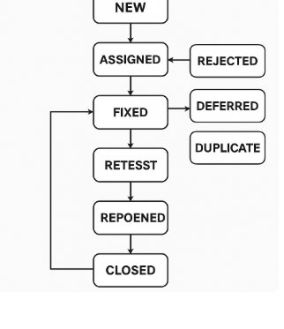
The Bug Life Cycle refers to the progression of a defect or bug through various stages from its identification to its final closure. It helps in tracking and managing bugs efficiently during software testing.

Stages of the Bug Life Cycle
Stage | Description
1. New | When a tester detects a new bug, it is assigned the "New" status and logged in the defect tracking tool.
2. Assigned | The bug is assigned to a developer by the test lead or manager for fixing.
3. Open | The developer has accepted the bug and started analyzing it.
4. In Progress / Fixed | The developer makes the required code changes and marks the bug as “Fixed”.
5. Retest | The bug is passed to the testing team for re-verification.
6. Verified | If the bug no longer exists, the tester marks it as “Verified”.
7. Closed | After verification, the bug is marked as “Closed” if it is resolved.
8. Reopened | If the issue still exists during retesting, it is “Reopened” and reassigned to the developer.
9. Rejected / Not a Bug | The developer may reject the bug if it's invalid, not reproducible, or not considered a bug.
10. Deferred / Postponed | The bug is valid but will be fixed in a later release due to low priority or other constraints.
11. Duplicate | The bug has already been reported earlier. It is marked as “Duplicate”.

Flow Diagram of Bug Life Cycle (Text Representation)
css
CopyEdit
[ New ]
↓
[ Assigned ]
↓
[ Open ]
↓
[ Fixed ]
↓
[ Retest ]
→ [ Reopened ] → [ Open ] → ...
↓
[ Verified ]
↓
[ Closed ]

Tools Used for Tracking Bug Life Cycle:
- JIRA
- Bugzilla
- Mantis
- Redmine
- Quality Center (HP ALM)

Why is Bug Life Cycle Important?
- Ensures proper tracking and communication between testers and developers.
- Helps to give priority and resolve critical issues on time.
- Improves quality control and customer satisfaction.

- What is defect repository? Explain with suitable example.
A Defect Repository (also known as a Bug Repository or Defect Tracking System) is a centralized database or system where all the identified defects (bugs) found during software development and testing are logged, tracked, and managed.

Purpose of a Defect Repository:
- To record details of defects (e.g., description, status, severity).
- To track progress of each bug through its life cycle.
- To analyze trends for improving product and process quality.
- To facilitate communication between testers, developers, and project managers.

Key Elements in a Defect Repository:
Field | Description
Bug ID | Unique identifier for each defect
Summary | Short description of the defect
Description | Detailed explanation of the issue
Severity & Priority | Indicates the impact and urgency
Status | Current state (New, Assigned, Fixed, Closed, etc.)
Reported By | Name of the tester or user who reported the defect
Assigned To | Developer responsible for fixing the issue
Steps to Reproduce | Clear steps to reproduce the issue
Environment | OS, browser, or platform where bug occurred
Attachments | Screenshots, logs, etc.

Example of a Defect Entry in the Repository:

Field | Value
Bug ID | BUG_1035
Summary | Login page crashes on invalid input
Description | App crashes when special characters are entered in username
Severity | High
Priority | Medium
Status | Assigned
Reported By | Tester_Asha
Assigned To | Dev_Rahul
Steps to Reproduce | 1. Open login page  2. Enter #!@ in username  3. Click Login
Environment | Windows 11, Chrome 118
Attachments | Screenshot_LoginCrash.png

Tools Used as Defect Repositories:
- JIRA
- Bugzilla
- Redmine
- Mantis
- HP ALM (Quality Center)

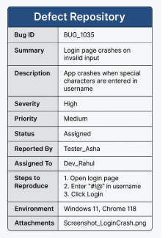

- Develop test case for Username and Password
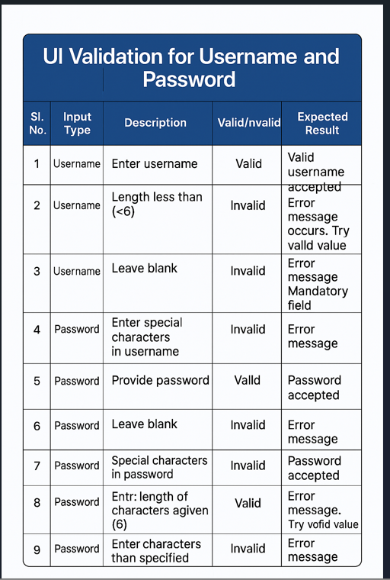

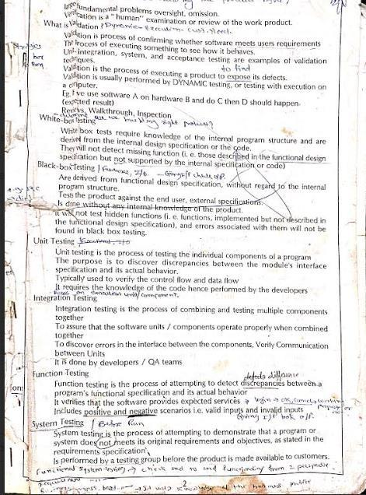
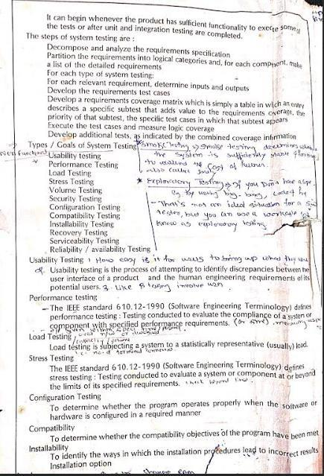
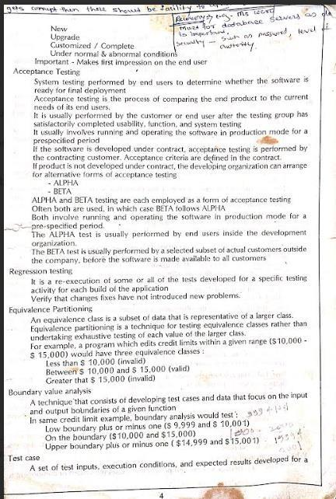
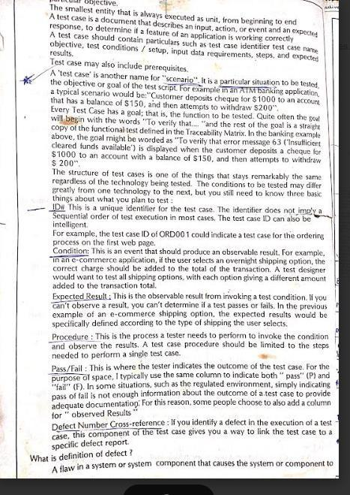
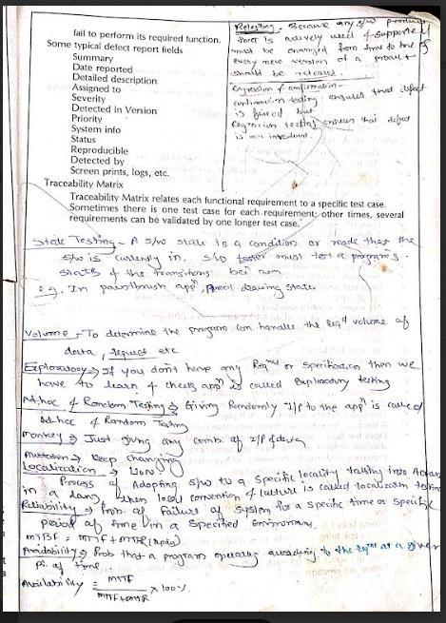

ATM TEST CASE
1. Functional Test Cases
Test Case ID | Description | Steps | Expected Result
TC01 | Verify card insertion | Insert valid ATM card | Card is read successfully
TC02 | Invalid card detection | Insert expired or damaged card | "Invalid Card" error shown
TC03 | Valid PIN entry | Enter correct 4-digit PIN | Access granted
TC04 | Invalid PIN entry | Enter wrong PIN 3 times | Card is blocked, error shown
TC05 | Balance inquiry | Select "Balance Inquiry" after login | Display correct account balance
TC06 | Cash withdrawal | Select "Withdraw", enter amount ₹500 | Dispense ₹500 if balance sufficient
TC07 | Insufficient balance | Withdraw more than available balance | Show "Insufficient funds"
TC08 | Cash deposit | Select "Deposit", insert envelope or cash | Update balance, show confirmation
TC09 | Mini-statement | Request mini-statement | Print last 5–10 transactions
TC10 | PIN change | Select "Change PIN", enter new PIN twice | Update PIN and show success

✅ 2. UI Test Cases
Test Case ID | Description | Steps | Expected Result
TC11 | Verify main screen layout | Power on ATM | Buttons, language selection, card slot clearly visible
TC12 | Language change | Select "Marathi" or "Hindi" | Interface language updates correctly
TC13 | Touchscreen response | Tap each option | Fast, accurate touch response
TC14 | Error message clarity | Enter invalid PIN | Clear, readable error message shown
TC15 | Cancel operation | Press "Cancel" mid-transaction | Return to welcome screen

✅ 3. Boundary & Limit Test Cases
Test Case ID | Description | Steps | Expected Result
TC16 | Max withdrawal limit | Try to withdraw ₹25,000 (if limit is ₹20,000) | Show "Limit Exceeded"
TC17 | Minimum amount | Try to withdraw ₹50 (if min is ₹100) | Show "Below Minimum Limit"
TC18 | Card session timeout | Insert card and stay idle | Auto-cancel transaction after timeout
TC19 | PIN length validation | Enter 3-digit or 5-digit PIN | Show "Invalid PIN format"
TC20 | Daily transaction count | Perform more than allowed number of daily transactions | Show "Daily Limit Reached"

✅ 4. Security Test Cases
Test Case ID | Description | Steps | Expected Result
TC21 | Shoulder-surfing prevention | Observe ATM usage from behind | PIN is masked (****)
TC22 | Session termination | Do not press "Exit" after transaction | Session auto-ends after timeout
TC23 | Skimming detection | Check for unauthorized devices | Alert raised if suspicious device found
TC24 | Card trapping attempt | Try to pull back card forcefully | ATM retracts card, locks it
TC25 | Power failure | Turn off power during transaction | ATM rolls back incomplete transaction

✅ 5. Integration Test Cases
Test Case ID | Description | Steps | Expected Result
TC26 | Bank database sync | Withdraw ₹1000 from ATM | Amount debited in real-time from account
TC27 | Notification system | Complete withdrawal | SMS/email sent with details
TC28 | Inter-bank transaction | Use different bank's card | ATM processes request via network
TC29 | Currency mismatch | Withdraw from foreign account | Currency conversion shown
TC30 | Receipt printing | Complete any transaction | Receipt printed with correct data

PASSWORD TEST CASE

1. Functional Test Cases
Test Case ID | Description | Test Steps | Expected Result
TC01 | Verify correct password | Enter valid password and submit | Login successful
TC02 | Verify incorrect password | Enter wrong password and submit | Error message: "Invalid password"
TC03 | Empty password field | Leave password field blank and submit | Error: "Password is required"
TC04 | Case sensitivity check | Enter same password in different case (e.g., "Password" vs "password") | Treat as different passwords
TC05 | Password with special characters | Enter password like "Pa$$w0rd!" | Accepted if valid
TC06 | Password with spaces | Enter password with leading/trailing spaces | Spaces either trimmed or error shown

✅ 2. Boundary & Limit Test Cases
Test Case ID | Description | Test Steps | Expected Result
TC07 | Minimum length password | Enter password with exactly minimum characters (e.g., 6) | Accepted
TC08 | Below minimum length | Enter 5 characters (if min is 6) | Error: "Password too short"
TC09 | Maximum length password | Enter password with max allowed length (e.g., 20) | Accepted
TC10 | Above maximum length | Enter 21 characters | Error: "Password too long"
TC11 | Password with only numbers | Enter "12345678" | Accepted/rejected per policy
TC12 | Password with only letters | Enter "abcdefgh" | Accepted/rejected per policy

✅ 3. UI/UX Test Cases
Test Case ID | Description | Test Steps | Expected Result
TC13 | Password masking | Enter password | Characters appear as *** or •
TC14 | Show/hide toggle | Click "eye" icon | Password becomes visible/invisible
TC15 | Password field focused | Click into password field | Cursor appears, field highlights
TC16 | Paste password | Copy and paste password into field | Paste accepted or blocked as per requirement

✅ 4. Security Test Cases
Test Case ID | Description | Test Steps | Expected Result
TC17 | Brute-force prevention | Try wrong password 5 times | Account locked or CAPTCHA shown
TC18 | SQL Injection in password | Enter ' OR '1'='1 | Input sanitized, error shown
TC19 | Clipboard clearing | Paste password and navigate away | Password not retained in clipboard
TC20 | Session timeout | Enter password but stay idle | Session expires, user logged out

✅ 5. Password Strength Test Cases (For Signup Forms)
Test Case ID | Description | Test Steps | Expected Result
TC21 | Weak password | Enter "123456" | Show "Weak Password" warning
TC22 | Strong password | Enter "Xyz@1234$" | Show "Strong Password" message
TC23 | Password policy enforcement | Enter password missing uppercase | Error: "Must include uppercase letter"
TC24 | Confirm password mismatch | Enter different values in Password and Confirm Password | Error: "Passwords do not match"
TC25 | Password reuse restriction | Try old password | Show: "Password already used"

SEI/CMM

SOFTWARE ENGG INSTITUTE/CAPABILITY MATURITY MODEL(NOW CALLED CMMI, CAPABILITY MATURITY MODEL INTEGRATION)

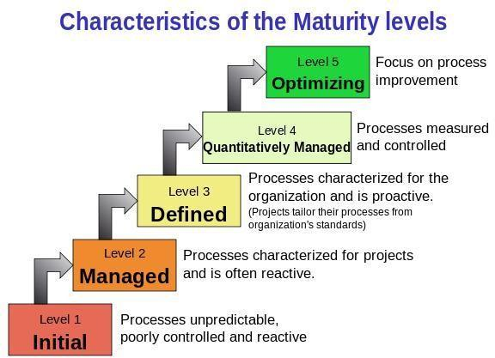
- It’s a 5 level of process maturity that determine effectiveness in delivering quality software.

Level 1: INITIAL
-Characterized by chao (not used standards)
-Efforts are required for complete project
-Not used standardized process method
But success oocur, so it is not guarented to say that success may be repetable.
- Processes are ad-hoc, chaotic, and unpredictable. Success depends on individual effort.

Level 2: MANAGED
-Requirement management,
-configuration management ,
-realistic planning process is used.
- Basic project management processes are established, and successes can be repeated.

Level 3 : DEFINED

-Standard development and maintenance process are used in organization
-Training programs are used to ensure understanding and compliance
- Standard software development processes are defined and documented.

Level 4: QUANTITATIVELY MANAGED
-Matrics are used to track productivity
-also used processes and products
-performance is predictable
-Quality is consistently high
- Processes are monitored and controlled through data collection and analysis.
Level 5: OPTIMIZED

-The focus is on continuous improvement.
-New process and technologies can be effectively implemented when require.
- Processes are constantly improved through feedback and innovation.
Bug

Defination: A bug in software refers to an error, flaw, or fault that causes a program to produce an incorrect or unexpected result, or behave in unintended ways.
The Bug Life Cycle is a structured process that tracks a bug from its initial discovery to its resolution, ensuring efficient bug management and improved software quality.
Bug Types:
Bugs can be classified based on various factors, including:

Severity:
How severely the bug impacts the software's functionality (e.g., critical, major, minor, trivial).

Priority:
How urgent it is to fix the bug (e.g., high, medium, low).

Reproducable:

Whether the bug can be consistently reproduced by different users or testers.

Scope:
Whether the bug is localized to a specific module or affects the entire application.
Bug Life Cycle Stages:
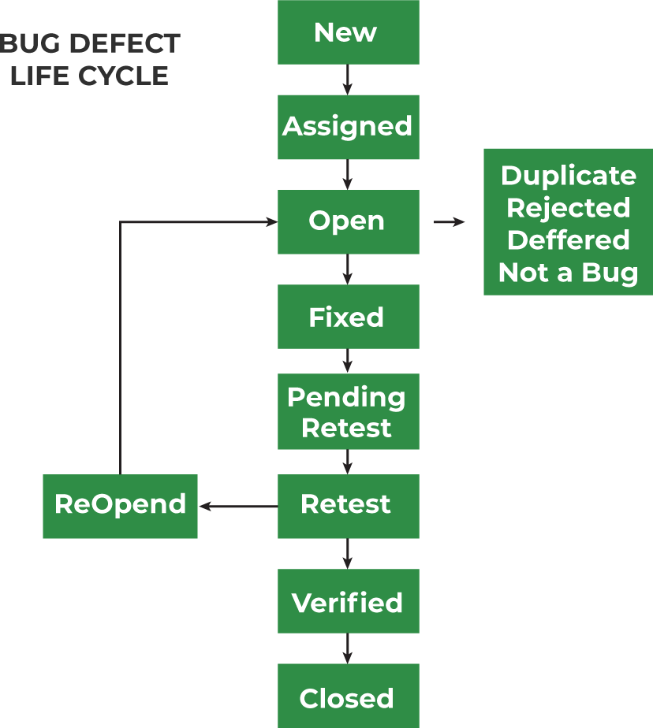
The bug life cycle typically involves the following stages:

- New
-Whenever a new defect is registered and posted for the first time, a “NEW” status is assigned to it.
-The tester offers a detailed defect/bug report to the Development team for resolving bug.

- Assigned
-After the tester posts the bug, the tester’s lead authorises the bug and assigns it to the developer team.
-In this stage, there can be two conditions. Firstly, the defect can be directly assigned to the developer.
-Secondly, it can be assigned to the Dev Lead and after being approved by the Dev Lead, they can further transfer the defect to the developer.
- ​Open

-In this stage, the developer begins to analyse and resolve the defect.
- If the developer team perceives that the defect is inappropriate, it is moved to either the ‘Deferred’ or the ‘Rejected’ state.

​Fixed
-A developer assigns a “Fixed” status to a bug after making a relevant code change and verifying the change.

5. Test
-The bug status as “Test” indicates that the defect is fixed and is ready to perform the test.
-The test is done to verify that the bug is fixed.

​Verified

-In this stage, the tester re-tests the bug after being fixed by the developer.
- In case the bug is not reproduced, the bug is considered fixed, and a “verified” status is assigned to it.

- ​Closed
-If the bug is resolved, the tester allocates the “Closed” status to it.
-After the bug is fixed, the tester tests it. This stage indicates that the bug is fixed, tested, and validated.

- ​Reopen
-In certain scenarios, the bug exists even after the developer has resolved it.
-In those cases, the tester assigns a “Reopen” state to the bug.
Here, the bug passes through the same life
cycle again after the “Reopen” bug is moved to “fixed” state.

​Duplicate

Sometime, the same bug may be reported twice. In that case, the bug status is modified to “duplicate.” and, the defect is rejected.

​Deferred

The tester team assigns a “Deferred” state to bugs in the following cases:
-If the bug is not of key priority and is expected to be resolved in the forthcoming release.
-The customer will modify the requirement
Note that the high-priority bugs can’t and should not be deferred.
- ​Rejected

-If the developer perceives that the defect is due to misinterpretation or is not genuine, they will assign a “Rejected” state to the defect. Usually, the reason for rejection may be one of the following:

NOT a Defect Duplicate Defect Non-Reproducible
Severity vs Priority

Bug vs Defect vs Error vs Fault vs Failure
1.

Bug
A bug refers to defects which means that the software product or the application is not working as per the adhered requirements set
Raised by
Test Engineers
- Different types
- Logical bugs
- Algorithmic bugs
- Resource bugs
- Reasons behind
- Missing Logic
- Erroneous Logic
- Redundant codes

Defect
A Defect is a deviation between the actual and expected output
The defect is identified by The Testers And is resolved by developers in the development phase of SDLC.
- Different types
Defects are classified as follows:
Based on Priority:
- High
- Medium
- Low
Based on Severity:
- Critical
- Major
- Minor
- Trivial
- Reasons behind
- Receiving & providing incorrect input

Defect
- Coding/Logical Error leading to the breakdown of software
- Way to prevent
- Implementing Out-of-the-box programming methods.
- Proper usage of primary and correct software coding practices.

Fault
A Fault is a state that causes the software to fail and therefore it does not achieve its necessary function.
Human mistakes lead to fault.
- Types

Fault
- Business Logic Faults
- Functional and Logical Faults
- Graphical User Interface (GUI) Faults
- Performance Faults
- Security Faults
- Hardware Faults
- Reason behind
- Wrong design of the data definition processes.
- An irregularity in Logic or gaps in the software leads to the non-functioning of the software.

Error
An Error is a mistake made in the code due to which compilation or execution fails,
Developers and automation test engineers
- Types
- Syntactic Error
- UI screen error
- Error handling error
- Flow control error
- Calculation error
- Hardware error
- Reason behind:
- Error in code.
- Inability to compile/execute a program
- Misunderstanding of requirements
- Faulty design and architecture
- Logical error

Failure
Failure is the accumulation of several defects that ultimately lead to Software failure and results in the loss of information
The failure is found by the test engineer during the development cycle of SDLC
Types:
NA
- Reason:
- Environment variables
- System Errors
- Human Error

TEST PLAN TEMPLATE
Test Plan Template:

(Name of the Product)

Prepared by:

(Names of Preparers)

(Date)

TABLE OF CONTENTS

1.0 INTRODUCTION

- OBJECTIVES AND TASKS

  - Objectives
  - Tasks

3.0 SCOPE

- Testing Strategy

  - Alpha Testing (Unit Testing)
  - System and Integration Testing
  - Performance and Stress Testing

  - User Acceptance Testing
  - Batch Testing
  - Automated Regression Testing
  - Beta Testing

5.0 Hardware Requirements

- Environment Requirements

  - Main Frame
  - Workstation

7.0 Test Schedule

8.0 Control Procedures

9.0 Features to Be Tested

10.0 Features Not to Be Tested
The seven principles of software testing are:
- Testing shows the presence of defects, not their absence. 2
- Exhaustive testing is impossible.
- Early testing saves time and money.
- Defects cluster together.
- Beware the pesticide paradox.
- Testing is context-dependent.
- The absence of errors is a fallacy.

Here's a more detailed explanation:
1. Testing shows the presence of defects, not their absence:
Testing can defects, but it cannot prove that a system is completely defect-free.
2. Exhaustive testing is impossible:
It's not feasible to test all possible combinations of inputs, preconditions, and scenarios.
3. Early testing saves time and money:
Starting testing early in the development lifecycle helps identify and fix defects sooner, reducing costs.
4. Defects cluster together:
A small number of modules or components often contain the majority of defects.
5. Beware the pesticide paradox:
Running the same tests repeatedly will eventually fail to find new defects. Test cases need to be updated and revised.
6. Testing is context-dependent:
The approach to testing should be tailored to the specific context of the project, including the application type, risk level, and user requirements.
- 7. The absence of errors is a fallacy:
A system can be technically defect-free but still not meet user needs
or be unusable.

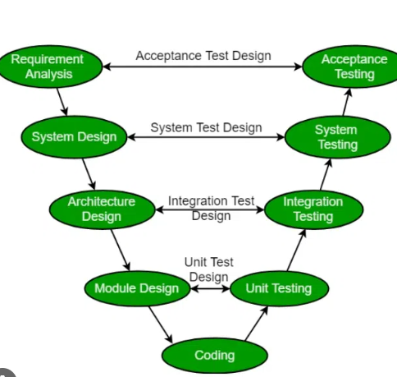

The V-model in software testing is a Software Development Life Cycle (SDLC) model that emphasizes verification and validation, visually represented as a "V" shape. It links each development phase with a corresponding testing phase, ensuring rigorous testing at each stage. The left side of the "V" represents development phases (requirements, design, etc.), while the right side mirrors those with testing phases (unit testing, integration testing, etc.).
Development (Left Side of the V):
- Requirements Analysis: Defining the system's overall functionality and features.
- System Design: High-level design of the system architecture and components.
- Architectural Design: Detailed design of specific modules and their interactions.
- Module Design: Designing individual modules and their internal logic.
- Coding: Actual programming of the software modules.
Testing (Right Side of the V):
- Unit Testing: Testing individual components or modules in isolation.
- Integration Testing: Testing the interaction between different modules.
- System Testing: Testing the entire system against the specified requirements.
- Acceptance Testing: Testing by the end-user to ensure the system meets their needs.

Black Box Testing Vs White Box Testing
Parameters | Black Box Testing | White Box Testing
Definition | Black Box Testing is a way of software testing in which the internal structure or the program or the code is hidden and nothing is known about it. | White Box Testing is a way of testing the software in which the tester has knowledge about the internal structure or the code or the program of the software.
Testing objectives | Black box testing is mainly focused on testing the functionality of the software, ensuring that it meets the requirements and specifications. | White box testing is mainly focused on ensuring that the internal code of the software is correct and efficient.
Testing methods | Black box testing uses methods like Equivalence Partitioning, Boundary Value Analysis, and Error Guessing to create test cases. | White box testing uses methods like Control Flow Testing, Data Flow Testing and Statement Coverage Testing.
Knowledge level | Black box testing does not require any knowledge of the internal workings of the software, and can be performed by testers who are not familiar with programming languages. | White box testing requires knowledge of programming languages, software architecture and design patterns.
Scope | Black box testing is generally used for testing the software at the functional level. | White box testing is used for testing the software at the unit level, integration level and system level.
Implementation | Implementation of code is not needed for black box testing. | Code implementation is necessary for white box testing.
Done By | Black Box Testing is mostly done by software testers. | White Box Testing is mostly done by software developers.
Terminology | Black Box Testing can be referred to as outer or external software testing. | White Box Testing is the inner or the internal software testing.
Testing Level | Black Box Testing is a functional test of the software. | White Box Testing is a structural test of the software.
Testing Initiation | Black Box testing can be initiated based on the requirement specifications document. | White Box testing of software is started after a detail design document.
Programming | No knowledge of programming is required. | It is mandatory to have knowledge of programming.
Testing Focus | Black Box Testing is the behavior testing of the software. | White Box Testing is the logic testing of the software.
Applicability | Black Box Testing is applicable to the higher levels of testing of software. | White Box Testing is generally applicable to the lower levels of software testing.
Alternative Names | Black Box Testing is also called closed testing. | White Box Testing is also called as clear box testing.
Time Consumption | Black Box Testing is least time consuming. | White Box Testing is most time consuming.
Suitable for Algorithm Testing | Black Box Testing is not suitable or preferred for algorithm testing. | White Box Testing is suitable for algorithm testing.
Approach | Can be done by trial and error ways and methods. | Data domains along with inner or internal boundaries can be better tested.
Example | Search something on google by using keywords | By input to check and verify loops
Exhaustiveness | It is less exhaustive as compared to white box testing. | It is comparatively more exhaustive than black box testing.

- INTRODUCTION

A brief summary of the product being tested. Outline all the functions at a high level.

- OBJECTIVES AND TASKS

- Objectives

Describe the objectives supported by the Master Test Plan, eg., defining tasks and responsibilities, vehicle for communication, document to be used as a service level agreement, etc.

- Tasks

List all tasks identified by this Test Plan, i.e., testing, post-testing, problem reporting, etc.

3.0 SCOPE

General

This section describes what is being tested, such as all the functions of a specific product, its existing interfaces, integration of all functions.

Tactics

List here how you will accomplish the items that you have listed in the "Scope" section. For example, if you have mentioned that you will be testing the existing interfaces, what would be the procedures you would follow to notify the key people to represent their respective areas, as well as allotting time in their schedule for assisting you in accomplishing your activity?

4.0 TESTING STRATEGY

Describe the overall approach to testing. For each major group of features or feature combinations, specify the approach which will ensure that these feature groups are
adequately tested. Specify the major activities, techniques, and tools which are used to test the designated groups of features.

The approach should be described in sufficient detail to permit identification of the major testing tasks and estimation of the time required to do each one.

- Unit Testing

Definition:

Specify the minimum degree of comprehensiveness desired. Identify the techniques which will be used to judge the comprehensiveness of the testing effort (for example, determining which statements have been executed at least once). Specify any additional completion criteria (for example, error frequency). The techniques to be used to trace requirements should be specified.

Participants:

List the names of individuals/departments who would be responsible for Unit Testing.

Methodology:

Describe how unit testing will be conducted. Who will write the test scripts for the unit testing, what would be the sequence of events of Unit Testing and how will the testing activity take place?

- System and Integration Testing

Definition:

List what is your understanding of System and Integration Testing for your project.

Participants:

Who will be conducting System and Integration Testing on your project? List the individuals that will be responsible for this activity.

Methodology:

Describe how System & Integration testing will be conducted. Who will write the test scripts for the unit testing, what would be sequence of events of System & Integration Testing, and how will the testing activity take place?

- Performance and Stress Testing

Definition:

List what is your understanding of Stress Testing for your project.

Participants:

Who will be conducting Stress Testing on your project? List the individuals that will be responsible for this activity.
Methodology:

Describe how Performance & Stress testing will be conducted. Who will write the test scripts for the testing, what would be sequence of events of Performance & Stress Testing, and how will the testing activity take place?

- User Acceptance Testing

Definition:

The purpose of acceptance test is to confirm that the system is ready for operational use. During acceptance test, end-users (customers) of the system compare the system to its initial requirements.

Participants:

Who will be responsible for User Acceptance Testing? List the individuals' names and responsibility.

Methodology:

Describe how the User Acceptance testing will be conducted. Who will write the test scripts for the testing, what would be sequence of events of User Acceptance Testing, and how will the testing activity take place?

- Batch Testing

- Automated Regression Testing

Definition:

Regression testing is the selective retesting of a system or component to verify that modifications have not caused unintended effects and that the system or component still works as specified in the requirements.

Participants:

Methodology:

4.7 Beta Testing

Participants:

Methodology:

5.0 HARDWARE REQUIREMENTS

Computers
Modems

- ENVIRONMENT REQUIREMENTS

- Main Frame

Specify both the necessary and desired properties of the test environment. The
specification should contain the physical characteristics of the facilities, including the hardware, the communications and system software, the mode of usage (for example, stand-alone), and any other software or supplies needed to support the test. Also specify the level of security which must be provided for the test facility, system software, and proprietary components such as software, data, and hardware.

Identify special test tools needed. Identify any other testing needs (for example, publications or office space). Identify the source of all needs which are not currently available to your group.

- Workstation

7.0 TEST SCHEDULE

Include test milestones identified in the Software Project Schedule as well as all item transmittal events.

Define any additional test milestones needed. Estimate the time required to do each testing task. Specify the schedule for each testing task and test milestone. For each testing resource (that is, facilities, tools, and staff), specify its periods of use.

8.0 CONTROL PROCEDURES

Problem Reporting

Document the procedures to follow when an incident is encountered during the testing process. If a standard form is going to be used, attach a blank copy as an "Appendix" to the Test Plan. In the event you are using an automated incident logging system, write those procedures in this section.

Change Requests

Document the process of modifications to the software. Identify who will sign off on the changes and what would be the criteria for including the changes to the current product. If the changes will affect existing programs, these modules need to be identified.

9.0 FEATURES TO BE TESTED

Identify all software features and combinations of software features that will be tested.

10.0 FEATURES NOT TO BE TESTED

Identify all features and significant combinations of features which will not be tested and the reasons.

11.0 RESOURCES/ROLES & RESPONSIBILITIES

Specify the staff members who are involved in the test project and what their roles are going to be (for example, Mary Brown (User) compile Test Cases for Acceptance Testing). Identify groups responsible for managing, designing, preparing, executing, and resolving the test activities as well as related issues. Also identify groups responsible for providing the test environment. These groups may include developers, testers, operations staff, testing services, etc.

12.0 SCHEDULES

Major Deliverables

Identify the deliverable documents. You can list the following documents:
- Test Plan
- Test Cases
- Test Incident Reports
- Test Summary Reports

13.0 SIGNIFICANTLY IMPACTED DEPARTMENTS (SIDs)

Department/Business Area Bus. Manager Tester(s)

14.0 DEPENDENCIES

Identify significant constraints on testing, such as test-item availability, testing-resource availability, and deadlines.

15.0 RISKS/ASSUMPTIONS

Identify the high-risk assumptions of the test plan. Specify contingency plans for each (for example, delay in delivery of test items might require increased night shift scheduling to meet the delivery date).

16.0 TOOLS

List the Automation tools you are going to use. List also the Bug tracking tool here.

17.0 APPROVALS

Specify the names and titles of all persons who must approve this plan. Provide space for the signatures and dates.

Name (In Capital Letters) Signature Date
1.

2.

3.

4.

End.

